DRIVE AND KICK DRILL

Purpose:
This drill teaches your players how to explode off the dribble and attack gaps in the defense, forcing defenders to help, before passing it out to a teammate for an open shot. To keep the drill fun and competitive, the last player takes a shot from the corner.

Setup:
- One player under the ring with a basketball.
- One player on each corner and one at the top of the key.
- The rest of your players on the baseline waiting to come in.

Instructions: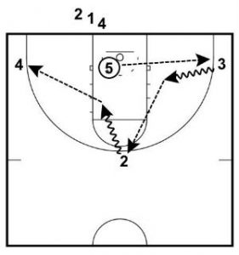
1. The player with the ball under the ring will pass it to 3 in the corner and then fill their place.
2. 3 will attack the key with two hard dribbles before passing to 2 at the top of the key and then fill their place.
3. 2 will also attack the key with two hard dribbles before passing to 4 and then will fill their place.
4. 4 will take the shot from the corner and then join the end of the line.
5. The next person in the line out of bounds will rebound the shot by 4 and pass it to the corner.
6. Repeat for the required amount of minutes.

Scoring System:
- Can run the drill as a full team or split the group in half and use both ends of the court.
- The drill is run against a time limit. I usually run it for 2 or 3 minutes.
1. The corner three-pointer is worth 3 points.
2. If the rebounder catches the ball before it hits the ground a put-back is worth 2 points.

